 

**LOAD ASPECT RECOGNITION BASED DATA COMPRESSION IN SMART METERS**

**A PROJECT REPORT**

**Submitted by**

|  |  |
| --- | --- |
| **K.ANUPALLAVI**  **M.BINCY IMMACULATE**  **U.LOGESWARI**  **D.SELVA MARY** | **211413205011**  **211413205021**  **211413205051**  **211413205093** |
|  |  |

**in partial fulfillment for the award of the degree**

**of**

**BACHELOR OF TECHNOLOGY**

**in**

**INFORMATION TECHNOLOGY**

**PANIMALAR ENGINEERING COLLEGE, POONAMALLEE**

**ANNA UNIVERSITY:: CHENNAI 600 025**

**APRIL 2017**

**BONAFIDE CERTIFICATE**

Certified that this project report **“LOAD ASPECT RECOGNITION BASED DATA COMPRESSION IN SMART METERS”** is the bonafide work of work**“K.ANUPALLAVI, M.BINCY IMMACULATE, U.LOGESWARI, D.SELVA MARY”** who carried out the project work under my supervision.

**SIGNATURE SIGNATURE**

DR.M.HELDA MERCY M.E,Ph.D., Mrs.S.UMA,M.Tech.,

**HEAD OF THE DEPARTMENT ASSISTANT PROFESSOR**

INFORMATION TECHNOLOGY INFORMATIONTECHNOLOGY

PanimalarEngineering College, Panimalar Engineering College,

Poonamallee, Poonamallee,

Chennai-600 123. Chennai-600 123.

Submitted for the project and viva-voice examination held on

**SIGNATURE SIGNATURE**

**INTERNAL EXAMINER EXTERNAL EXAMNER**

**DECLARATION**

I here by declare that the project report entitled “**LOAD ASPECT RECOGNITION BASED DATA COMPRESSION IN SMART METERS”**which is being submitted in partial fulfillment of the requirement of the course leading to the award of the ‘Bachelor Of Technology in Information Technology’ in **Panimalar Engineering College , Affiliated to Anna University –Chennai** is the result of the project carried out by me under the guidance and supervision of **Mrs.S.UMAM.Tech., Assistant Professor in the Department of Information Technology**. I further declared that I or any other person has not previously submitted this project report to any other institution / university for any other degree/diploma or any other person.

Signature of batch members

(K.ANUPALLAVI)

(M.BINCYIMMACULATE)

(U.LOGESWARI)

(D.SELVA MARY)

It is certified that this project has been prepared and submitted under my guidance.

Date: **Mrs.S.UMAM.Tech.,**

Place: Chennai (Assistant Professor/IT)

**ACKNOWLEDGEMENT**

A project of this magnitude and nature requires kind co-operation and support from many, for successful completion .We wish to express our sincere thanks to all those who were involved in the completion of this project.

We would like to express our deep gratitude to our respected Secretary and Correspondent,**Dr.P.CHINNADURAI, M.A., Ph.D.,** Secretary and correspondent,for his sincere endeavour in educating us in the premier institution.

We also express our sincere thanks to Our honorable Directors **Mrs. C. VIJAYA RAJESHWARI**  and **Mr. C. SAKTHI KUMAR, M.E.,**and **Mrs. SARANYA SREE SAKTHI KUMAR,B.E.,** for providing us with the necessary facilities for completion of this project.

We are grateful to our Principal, **Dr. K. MANI, M.E., Ph.D,** .Panimalar Engineering College , who helped us in he completion of the project. We wish to convey our thanks and gratitude to our head of the department, **Dr.M. HELDA MERCY, M.E., Ph.D.,** Department Of Information Technology, for her support and by providing us ample time to complete our project.

We express our indebtedness and gratitude to our project co-ordinator **Mrs,S.UMA,M.Tech.,** Assistant Professor, Department Of Information Technology. Last, we thanks our parents and friends for providing their extensive moral support and encouragement during the course of the project.

**ABSTRACT**

Power Line Carrier Communication (PLCC) has as of late pulled in the consideration of vitality organizations as a helpful and common innovation for building the advanced prepaid metering infrastructure and to balance the electricity without fluctuation. The voltage fluctuation is also reduced. The customer and the system can be interacted without the help of EB officers. This system particularly focus on the activities of power line communication technology and provide the electricity to the customer without any fluctuation till the maximum level of electricity consumption is reached. A person need not go to EB station for billing and payment.The proposed system of our project to stop the in the corruption in the electricity and to reduce the hard task in handling and maintaining the power as per the growing requirements. In this proposed system we used the WIFI technology for transmitting and receiving the data.

|  |  |  |
| --- | --- | --- |
|  | **TABLE OF CONTENTS** |  |
| **CHAPTER NO** | **TITLE** | **PAGE NO** |
|  | **ABSTRACT** |  |
|  | **TABLE OF CONTENTS** |  |
|  | **LIST OF FIGURES** |  |
|  | **LIST OF TABLES** |  |
|  | **LIST OF ABBREVIATIONS** |  |
| **1** | **INTRODUCTION** | 1 |
|  | * 1. Purpose   2. Scope | 1  2 |
| **2** | **LITERATURE REVIEW** | 3 |
|  | Introduction | 3 |
|  | 2.1.1Purpose of Literature Survey | 3 |
|  | 2.1.2Related Works | 4 |
| **3** | **METHODOLOGY** | 6 |
|  | 3.1 Why do we need prepaid metering?  3.2 Advantages of Proposed system  3.3 Block Diagram  3.4 Process of proposed system  3.5 Applications | 6  6  7  8  9 |
| **4** | **HARDWARE MODULE** | 13 |
|  | 4.1 Microcontroller | 13 |
|  | 4.1.1 Features  4.1.2 Description  4.1.3 Pin Description | 13  14  16 |
|  | 4.2 Power Supply circuit | 20 |
|  | 4.2.1 Working Principle  4.2.2 Transformer  4.2.3 Bridge Recitifier  4.2.4 IC Voltage Regulator | 21  21  21  23 |
|  | 4.3 ADC 0808/0809 | 23 |
|  | 4.4 Buzzer | 24 |
|  | 4.5 Current sensor | 26 |
|  | 4.6 IR sensor | 26 |
|  | 4.6.1 Overview of IR Sensor  4.6.2 Object Detection Using IR Sensor | 26  27 |
|  | 4.7 LCD | 28 |
|  | 4.8 Voltage sensor | 31 |
| **5** | **SOFTWARE DESCRIPTION** | 36 |
|  | 5.1 Softwar Analysis  5.2 Keil Compiler  5.3 KeilMicrovision | 36  36  39 |
| **6** | **IMPLEMENTATION**  6.1 Embedded C coding for microcontroller  6.2 Screen shots | 40  40  51 |
| **7** | **CONCLUSION** | 53 |
|  | **REFERENCE** | 54 |

**APPENDIX**  55

**LIST OF FIGURES**

|  |  |  |
| --- | --- | --- |
| **FIGURE NO** | **TITLE** | **PAGE NO** |
| 3.3 | Block Diagram of Proposed System | 7 |
| 4.1.1 | Circuit Diagram of Proposed system | 15 |
| 4.1.4 | Working Diagram of Input/Output Ports | 19 |
| 4.1.5 | Oscillator Diagram | 20 |
| 4.2.1 | Circuit Diagram of Power Supply | 20 |
| 4.3.1 | ADC | 23 |
| 4.4 | Buzzer | 24 |
| 4.6.1 | Working Diagram of IR Sensor | 27 |
| 4.7.3 | LCD Interfacing with PIC | 30 |

**LIST OF TABLES**

|  |  |  |
| --- | --- | --- |
| **TABLE NO** | **TITLE** | **PAGE NO** |
| 4.1.2 | Functions of Port 1 | 16 |
| 4.1.3 | Functions of Port 3 | 17 |
| 4.6.2 | LCD Commands | 29 |

**LIST OF ABBREVIATIONS**

PLCC Power Line Carrier Communication

WAMRCS Wireless Arm based automatic Meter Reading

And Control System

RFID Radio Frequency Identification

SFR Special Function Register

ADC Analog to Digital Converter

RX Receiver

TX Transmitter

LCD Liquid Crystal Display

IDE Integrated Development Environment

**CHAPTER -1**

**INTRODUCTION**

**1.1 PURPOSE**

The traditional manual metering system brings disruption to users, and also wastes a lot of human energy and cost. With increasing electricity network the workload of electricity consumption is becoming high and the distribution management is also not easy. So, to avoid this issues the power line carrier communication (PLCC) transmission is introduced which can replace the usage of two wires, it can carry both data and power simultaneously. It also avoids voltage fluctuation, that can be made possible by providing the equal distribution of electricity till the maximum consumption of energy is reached and when there is more need to a particular house the fluctuation occurs, this is avoided by systematic use of the electricity fluctuation to the same house so that the nearer house are not affected and simultaneously the EB station gets a notification through a buzzer and provides extra electricity to that particular area, so this system benefits people and reduces man power. This Prepaid metering system gets an amount from RFID tag and reads it continuously which also deduce the amount accordingly for each unit of energy consumption, when the amount is reached half of the amount and also when the amount is zero it indicates the buzzer so ,that the user may be aware of the units of current consumed and can use accordingly and recharge respectively.

The major issues is that the occurrence of voltage fluctuation. This is reduced by equally distributing the electricity to all houses first and then if a particular house is consuming the energy more than the maximum level then there occurs a fluctuation to the near-by houses since the current is consumed more by one particular house, in-order to avoid this situation when there occurs fluctuation it is made systematic use to the same house which consumes more energy and then the issue is noted by the EB station so that he is then provided by extra electricity by allowing that particular house.

**1.2. SCOPE**

The scope of our project doesn’t limit to prepaid metering system but it also extends to avoid voltage fluctuation in our home. This system can be used to know the awareness of current consuming in our home.

This technology has been in wide use since 1950 and was mainly used by the grid stations to transmit information at high speed. Now a days this technology is finding wide use in building/[home automation](http://www.engineersgarage.com/articles/home-automation) as it avoids the need of extra wiring. The data collected from different [sensors](http://www.engineersgarage.com/articles/sensors) is transmitted on these power lines thereby also reducing the maintenance cost of the additional wiring. In some countries this technology is also used to provide Internet connection.

**CHAPTER -2**

**LITERATURE SURVEY**

**2.1 INTRODUCTION**

A literature Survey is an objective, critical summary of published research literature relevant to a topic under consideration for research. Its purpose is to create familiarity with current thinking and research on a particular topic, and may justify future research into a previously overlooked or understudied area. It is the most important part of the report as it gives a direction in the area of research. It helps to set a goal for the analysis thus giving out problem statement. A literature review in respect of the project, the researches made by various analysts – their methodology (which is basically their abstract) and the conclusions they have arrived at. It also gives an account of how this research has influenced the thesis.

**2.1.1 Purpose of Literature Survey**

* Identifies gaps in current knowledge.
* Helps to avoid reinventing the wheel by discovering the research already conducted on a topic.
* Sets the background on what has been explored on a topic so far.
* Increases the breadth of knowledge in area of research.
* Helps to identify seminal works in particular area.

**2.2 RELATED WORKS**

**2.2.1.Automatic reading system based on automatic alignment control for pointer meter(2014)**

**Authors**:Wuhan Univ., Wuhan, China,[Yao He](http://ieeexplore.ieee.org/search/searchresult.jsp?searchWithin=) ,[Fei Yang](http://ieeexplore.ieee.org/search/searchresult.jsp?searchWithin=)

In perspective of the imperfections of acknowledgment estimation of the current high exactness pointer meter, we built up an arrangement of arrangement of programmed perusing in light of programmed arrangement control for pointer meter. We changed the current working table, added to an arrangement of arrangement of camera programmed arrangement, and achieved the camera pointed consequently in view of machine vision. With respect to esteem, we enhanced the customary separation technique, in the interim, extended the scale stamp and pointer through changing over polar arrange, and changed edge strategy in unique picture into the separation strategy in polar facilitate plane, so it is more precise for acknowledgment esteem according to the position relationship amongst pointer and neighbouring scale marks.

**2.2.2 The wireless automatic meter reading and control system based on STC12C5A60S2(2005)**

**Authors** :[Zhenjiang Cai](http://ieeexplore.ieee.org/search/searchresult.jsp?searchWithin=) ; [Jiejing Li](http://ieeexplore.ieee.org/search/searchresult.jsp?searchWithin=) ; [Meng Zhang](http://ieeexplore.ieee.org/search/searchresult.jsp?searchWithin=)

For meeting the practical needs of the rapid development in the electric power system, the automatic meter reading system is designed in this paper. The micro-controller STC12C5A60S2 is used as the core-component. The 485 circuit which is made up of the half duplex (HD) transceiver SN65LBC184 is used for data acquisition. The whole circuit is controlled by relay which connected with optical coupler in the system. After processing the data of electric meter collected by the acquisition module, it will be stored in the FERAM FM25256. Then the data could be sent to the power supply departments or customers periodically or according to the need. When the data is abnormal (deficiency of electric quantity, the abnormal current or voltage ), the control circuit should be powered down.

**2.2.3. Design of a Wireless ARM-Based Automatic Meter Reading and Control System(2004)**

**Authors** :Chih-Hung Wu, Shun-Chien Chang and Yu-Wei Huang

This paper executes a remote ARM-based programmed meter perusing and control framework (WAMRCS) for dissemination robotization. The WAMRCS is planned in light of a32-bit ARM chip to manage control information preparing and transfer control. So as to give a financially savvy, remote, constantly associated, two-way information connect between service organization and WAMRCS, the WAMRCS sends data of utility utilization, control quality and blackout alert to service organization by means of GPRS system. Contrasted and simple utility meter perusing by labour, WAMRCS is more precise, solid, practical, brisk and free from man-made mistake.

**CHAPTER -3**

**METHODOLOGY**

**3.1. WHY DO WE NEED PREPAID METERING?**

In existing system, the possibility to use the networks for the grid monitoring system has been explored. It is validated through a dedicated experimental set-up. Each smart meters is connected to the MDC by means of a performing broadband power line communication network. The major drawback of existing system is leads to the current loss if the person is not there in home and it is low efficiency, and the person cannot go to EB office if the power goes in the night.

In this proposed system we going to implement that A PLCC Based Reliable and Efficient Power Metering System for Energy Management Power metering system will monitor the consumed power in particular home and transmitted via PLCC. The bill payment section will be take place in home itself. RFID reader will detect the smart card and amount selection via keypad. Controller will check remaining amount continually, If balance is below certain level buzzer will be turn on. When the person is aware about the consumed electricity then there may be a chance of sustainable usage and the recharge can be done whenever required. It avoids low voltage (fluctuation) and balances the supply which is a basic need consumption and low voltage is directed to the high power consumed point. So, that the distributed power supply can be used efficiently.

**3.2 ADVANTAGES OF PROPOSED SYSTEM**

* simplifies the work of the electricity board in tripping then supply to a particular customer in case bill is not paid.
* It also reduces the difficulty faced by the people when readings are taken manually

**3.3 BLOCK DIAGRAM**

**IR SENSOR**

**ADC**

**Voltage sensor**

**Current sensor**

**X10 IC IC5051**

**AT89S52**

**Micro controller**

**16*2 LCD**

**RFID READER**

**Driver unit**

**HOME POWER SUPPLY**

**SINGLE PHASE**

**POWERLINE**

**X10 IC**

**IC5051**

**UART**

**AT89S52**

**MICRO CONTROLLER**

**PC**

**WEB SERVER**

**BUZZER**

TAG

Fig 3.3 Block Diagram Of Proposed System

**3.4 PROCESS OF PROPOSED SYSTEM:**

In this system the home station and the EB station are the two section in which the effective bill payment is done in home which can also reduce the energy consumption.This system includes a microcontroller which is used for control and execution of code.

The home section has an EB meter which is connected with RFID reader and tag for user account details.The keypad is used to select the range of amount needed for electricity.The current sensor and the voltage sensor are used for current and voltage recognition respectively.The readings are displayed using Liquid Crystal Display (LCD) where the current and voltage values are displayed.The Driver unit is a relay where serial connection of devices can be connected.The Data and the Power supply is carried simultaneously using a device power line carrier communication (PLCC) which reduces the time and increases efficiency by carrying both data and power in a single wire.This details are transmitted through PLCC to the EB station.

The EB station monitors all user details using visual basic the usage and the demand are monitored continuously and that are also transmitted through PLCC when the user exceeds their consumption the buzzer gives an alert so that the user can be aware of consumption.

The user can recharge the card whenever required.When the amount is reached zero then the power off automatically.

**3.5 APPLICATIONS**

[**Home Appliances**](http://www.atmel.com/applications/home_appliances/?Appid=1040):

More than ever, consumers have high expectations for home appliances. They demand sophisticated, feature-rich products that are reliable and easy to use. To meet these needs, developers of white goods need technology that provides:

* Advanced motor control features for safe, quiet operation.
* Green, power-efficient technology, as well as energy measurement and control through connectivity with smart metering networks.
* Advanced human machine interface (HMI) support through touch screen technology for a rich, easy user experience.
* Flexible, compatible connectivity to integrate devices with the outside world.
* Standards-based certification to enable reliable, high-quality solutions.

### [****Home Entertainment****](http://www.atmel.com/applications/home_entertainment/?Appid=2177):

### Home entertainment systems continue to evolve in size and sophistication, delivering new levels of experiences and adventure to consumers.

Home Entertainment has expanded to become a veritable indoor electronic playground for children and adults alike, with systems incorporating large-screen displays, gaming consoles, audio equipment, and docking stations.

And often this entertainment empire is completely controlled and managed through a single remote control. Atmel solutions for home entertainment help you address your most pressing design challenges, including:

* Delivering innovative capabilities that entice consumers to upgrade and expand.
* Responding to consumer demand for energy-saving solutions.
* Integrating wireless and touchscreen technologies.
* Connecting and protecting more home entertainment products.
* Robust RF interference protection.

### [****Industrial Automation****](http://www.atmel.com/applications/industrial_automation/default.asp?Appid=2178):

As industrial environments become more advanced and connected, automation technology is developing at a rapid pace. To deliver the communication features and intelligence required at the plant floor and beyond, developers need solutions that can provide:

* High performance together with power efficiency.
* Rugged environmental design to resist water, dust, moisture, and extreme temperatures.
* Advanced, yet cost effective Human Machine Interface (HMI) features.
* Support for high-speed wired and wireless communication.
* Dedicated features for functional safety implementation.

### [****Lighting****](http://www.atmel.com/applications/lighting/default.asp?Appid=2180):

Fluorescent and LED lights use 50 to 80 percent less energy than their incandescent counterparts. No wonder U.S. and European governments are pushing vendors for lighting solutions that rely on high frequency electronic ballasts. Successful ballast design depends on a few key tradeoffs:

* Balancing ease of use against design complexity and cost.
* Balancing voltage and current control against design complexity and board space.
* Balancing functionality against low power consumption.

### [****Metering****](http://www.atmel.com/applications/metering/?Appid=1024):

The market for energy, water, and gas metering systems is rapidly changing, driven by new environmental and conservation concerns and regulations.Traditional standalone meters are now being replaced by complex networked systems that utilize a variety of communication methods.To meet the needs of this evolving Smart Grid, metering developers need solutions that can provide:

* Intelligent support for application and communication stacks.
* Robust security functionality.
* Remote upgrades in the field.
* Support for communications protocols for home connectivity.

### [****Mobile Electronics****](http://www.atmel.com/applications/mobile_electronics/?Appid=2181):

Today's mobile products are changing the way people consume information, socialize, conduct business, and purchase products. Major technology revolutions have completely changed the landscape for mobile devices.

To meet the needs of increasingly mobile customers, designers require solutions that offer:

* Efficient power management to support portable devices on the move.
* Fast response time for nimble operation.
* Highly integrated design for small footprint and minimal BOM.
* Support for intuitive touch screen interfaces.
* Secure hardware authentication of accessories.

**CHAPTER -4**

**HARDWARE MODULE**

**4.1. MICROCONTROLLER**

### AT89s52 Microcontroller:

### The AT89S52 is a low-power, high-performance CMOS 8-bit microcontroller with 8K bytes of in-system programmable Flash memory. The device is manufactured using Atmel’s high-density nonvolatile memory technology and is compatible with the Indus-try-standard 80C51 instruction set and pin out.

### 4.1.1 FEATURES

### Compatible with MCS®-51 Products.

### 8K Bytes of In-System Programmable (ISP) Flash Memory – Endurance: 1000 Write/Erase Cycles.

### 4.0V to 5.5V Operating Range.

### Fully Static Operation: 0 Hz to 33 MHz.

### Three-level Program Memory Lock.

### 256 x 8-bit Internal RAM.

### 32 Programmable I/O Lines.

### Three 16-bit Timer/Counters.

### Eight Interrupt Sources.

### Full Duplex UART Serial Channel.

### Low-power Idle and Power-down Modes.

### Interrupt Recovery from Power-down Mode.

### Watchdog Timer.

### Dual Data Pointer.

### Power-off Flag.

### Fast Programming Time.

### Flexible ISP Programming (Byte and Page Mode).

### Green (Pb/Halide-free) Packaging Option.

### 4.1.2 DESCRIPTION

### The AT89S52 is a low-power, high-performance CMOS 8-bit microcontroller with 8K bytes of in-system programmable Flash memory.

### The device is manufactured using Atmel’s high-density nonvolatile memory technology and is compatible with the Indus-try-standard 80C51 instruction set and pin out.

### The on-chip Flash allows the program memory to be reprogrammed in-system or by a conventional nonvolatile memory pro-grammars. By combining a versatile 8-bit CPU with in-system programmable Flash on a monolithic chip, the Atmel AT89S52 is a powerful microcontroller which provides a highly-flexible and cost-effective solution to many embedded control applications.

### The AT89S52 provides the following standard features: 8K bytes of Flash, 256 bytes of RAM, 32 I/O lines, Watchdog timer, two data pointers, three 16-bit timer/counters, a six-vector two-level interrupt architecture, a full duplex serial port, on-chip oscillator, and clock circuitry.

### 

### Fig 4.1.1 Circuit Diagram of Microcontroller

### PIN DESCRIPTION

### VCC: Supply voltage.

### GND: Ground.

### Port 0: Port 0 is an 8-bit open drain bidirectional I/O port. As an output port, each pin can sink eight TTL inputs. When 1s are written to port 0 pins, the pins can be used as high-impedance inputs.

### Port 0 also receives the code bytes during Flash programming and outputs the code bytes during program verification. External pull-ups are required during program verification.

### Port 1: Port 1 is an 8-bit bidirectional I/O port with internal pull-ups. The Port 1 output buffers can sink/source four TTL inputs. When 1s are written to Port 1 pins, they are pulled high by the inter-nal pull-ups and can be used as inputs. As inputs, Port 1 pins that are externally being pulled low will source current (IIL) because of the internal pull-ups. In addition, P1.0 and P1.1 can be configured to be the timer/counter 2 external count input (P1.0/T2) and the timer/counter 2 trigger input (P1.1/T2EX), respectively.

|  |  |
| --- | --- |
| PORT PIN | ALTERNATE FUNCTION |
| P1.0 | T2(External Count Input To Timer/Count),Clock-Out |
| P1.1 | T2EX(Timer/Counter capture 2/reload trigger and direction control |
| P1.5 | MOSI(used for In-System Programming) |
| P1.6 | MISO(used for In –System Programming) |
| P1.7 | SCK(used for In-System Programming) |

Table 4.1.2 Functions of Port 1

### Port 2: Port 2 is an 8-bit bidirectional I/O port with internal pull-ups. The Port 2 output buffers can sink/source four TTL inputs. When 1s are written to Port 2 pins, they are pulled high by the internal pull-ups and can be used as inputs. As inputs, Port 2 pins that are externally being pulled low will source current (IIL) because of the internal pull-ups. Port 2 emits the high-order address byte during fetches from external program memory and during accesses to external data memory that uses 16-bit addresses (MOVX @ DPTR).

### Port 3: Port 3 is an 8-bit bidirectional I/O port with internal pull-ups. The Port 3 output buffers can sink/source four TTL inputs. As inputs, Port 3 pins that are externally being pulled low will source current (IIL) because of the pull-ups. Port 3 receives some control signals for Flash programming and verification.

|  |  |
| --- | --- |
| PORT PIN | ALTERNATE FUNCTIONS |
| P3.0 | RXD(Serial Input Port) |
| P3.1 | TXD(Serial Output Port) |
| P3.2 | INT0(External Interrupt 0) |
| P3.3 | INT1(External Interrupt 1) |
| P3.4 | T0(Timer 0 External Input) |
| P3.5 | T1(Timer 1 External Input) |
| P3.6 | WR(External Data Memory Write Strobe) |
| P3.7 | RD(External Data Memory Read Strobe) |

### Table 4.1.3 Functions of Port 3

### RST: Reset input. A high on this pin for two machine cycles while the oscillator is running resets the device. This pin drives high for 98 oscillator periods after the Watchdog times out. The DISRTO bit in SFR AUXR (address 8EH) can be used to disable this feature. In the default state of bit DISRTO, the RESET HIGH out feature is enabled.

### ALE/PROG: Address Latch Enable (ALE) is an output pulse for latching the low byte of the address during accesses to external memory. This pin is also the program pulse input (PROG) during Flash programming. In normal operation, ALE is emitted at a constant rate of 1/6 the oscillator frequency and may be used for external timing or clocking purposes. Note, however, that one ALE pulse is skipped during each access to external data memory.

### PSEN: Program Store Enable (PSEN) is the read strobe to external program memory. When the AT89S52 is executing code from external program memory, PSEN is activated twice each machine cycle, except that two PSEN activations are skipped during each access to external data memory.

### Watchdog Timer: The WDT is intended as a recovery method in situations where the CPU may be subjected to software upsets. The WDT consists of a 14-bit counter and the Watchdog Timer Reset (WDTRST) SFR. The WDT is defaulted to disable from exiting reset.

### Special Function Registers (SFR): Special function registers are part of RAM memory. Their purpose is predefined by the manufacturer and cannot be changed therefore. Since their bits are physically connected to particular circuits within the microcontroller, such as A/D converter, serial communication module etc., any change of their state directly affects the operation of the microcontroller or some of the circuits.

### Program Counter: Program Counter is an engine running the program and points to the memory address containing the next instruction to execute. After each instruction execution, the value of the counter is incremented by 1. For this reason, the program executes only one instruction at a time just as it is written.

### Input/output ports (I/O Ports): In order to make the microcontroller useful, it is necessary to connect it to peripheral devices.

### 

### Fig 4.1.4 Working diagram of Input and Output Ports

### Each microcontroller has one or more registers (called a port) connected to the microcontroller pins.

### Oscillator:

### 

### Fig 4.1.5 Oscillator diagram

### Even pulses generated by the oscillator enable harmonic and synchronous operation of all circuits within the microcontroller. It is usually configured as to use quartz-crystal or ceramics resonator for frequency stabilization. It can also operate without elements for frequency stabilization (like RC oscillator). It is important to say that program instructions are not executed at the rate imposed by the oscillator itself, but several times slower.

### Accordingly, if the system uses quartz crystal with a frequency of 20MHz, the execution time of an instruction is not expected 50nS, but 200, 400 or even 800 nS, depending on the type of the microcontroller.

### Timers/Counters: Most programs use these miniature electronic "stopwatches" in their operation. These are commonly 8- or 16-bit SFRs the contents of which is automatically incremented by each coming pulse. Once the register is completely loaded, an interrupt is generated!

### POWER SUPPLY CIRCUIT

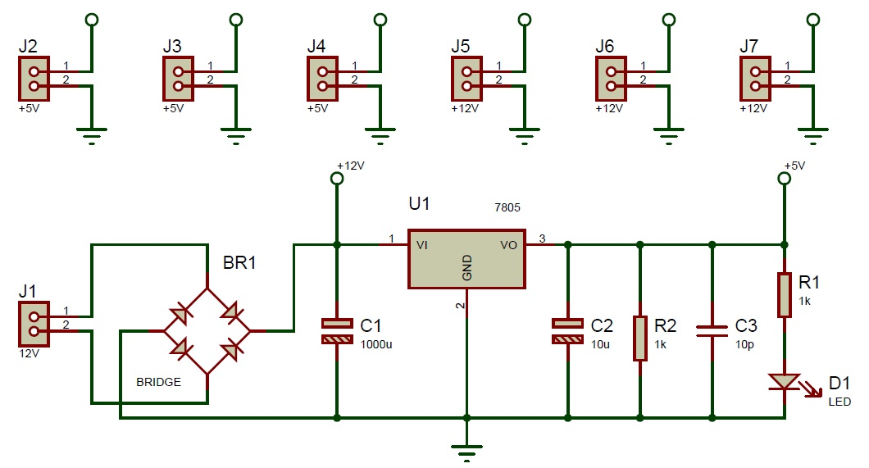

### Figure 4.2.1 Circuit Diagram of Power Supply

**4.2.1 WORKING PRINCIPLE**

The AC voltage, typically 220V rms, is connected to transformer, which steps that ac voltage down to the level of the desired DC output. A Diode rectifier provides a full-wave rectified voltage that is initially filtered by a simple capacitor filter to produce a dc voltage. This resulting dc voltage usually has some ripple or ac voltage variation .A regulator circuit removes the ripples and also remains the same dc value even if the input dc voltage varies, or the load connected to the output dc voltage changes.

**4.2.2 TRANSFORMER**

The potential transformer will step down the power supply voltage(0-230V) to (0-6) level. Then the secondary of the potential transformer will be connected to the precision rectifier, which is constructed with the help of op-amp. The advantages of using precision rectifier are it will give peak voltage output as DC, rest of the circuits will give only RMS output.

**4.2.3 BRIDGE RECTIFIER**

When four diodes are connected as shown in figure, the circuit is called as bridge rectifier. The input to the circuit is applied to the diagonally opposite concerns of the network, and the output is taken from the remaining two concerns.

Let us assume that the transformer is working properly and there is a positive potential, at point A and a negative potential at point B. The positive potential at point A will forward bias D3 and reverse bias D4.

The negative potential at point B will forward bias D1 and reverse D2.At this time D3 and D1 are forward biased and will allow current flow to pass through them;D4 and D2 are reverse biased and will block current flow.

The path for current flow is from point B through D1,up through RL, through D3,through the secondary of the transformer back to point B. This path is indicated by the solid arrows. Waveforms (1) and (2) can be observed across D1 and D3.

One-half cycle later the polarity across the secondary of the transformer reverse, forward biased D2 and D4 and reverse biased D1 and D3.Current flow will now be from point A through D4,up through RL, through D2,through the secondary of T1,and back to point A. This point is indicated by the broken arrows. Waveforms (3) and (4) can be observed across D2 and D4.The current flow through RL is always in the same direction.

In flowing through RL ,this current develops a voltage corresponding to that shown waveform (5).Since current flows through the load (RL) during both half cycles of the applied voltage, this bridge rectifier is a full-wave rectifier.

One advantage of a bridge rectifier over a conventional full-wave rectifier is that with a given transformer the bridge rectifier produces a voltage output that is nearly twice that of the conventional full-wave circuit.

This may be shown by assigning values to the components shown in views A and B. Assume that the same transformer used in both circuits. The peak voltage developed between points X and Y is 1000 volts in both circuits. In the conventional full- wave circuit shown in view A, the peak voltage from the center tap to either X or Y is 500 volts.

Since only one diode can conduct at any instant, the maximum voltage that can be rectified at any instant is 500 volts.

The maximum voltage that appears across the load resistor is nearly but never exceeds 500 volts, as result of the small voltage drop across the diode. In the bridge rectifier shown in view B, the maximum voltage that can be rectified is the full secondary voltage, which is 1000 volts. Therefore, the peak output voltage across the load resistor is nearly 1000 volts. With both circuit using the same transformer, the bridge rectifier circuit produces a higher output voltage than the conventional full-wave rectifier circuit.

**4.2.4 IC VOLTAGE REGULATORS**

Voltage regulator comprises a class of widely used ICs. Regulator IC units contains the circuitry for reference source, comparator amplifier, control device, and overload protection all in a single IC.IC unit provide regulation of either a fixed positive voltage, a fixed negative voltage or an adjustable set voltage. The regulator can be selected for operation with load currents from hundreds of milli amperes to tens of amperes, corresponding to power ratings from milli watts to tens of watts.

A fixed three-terminal voltage regulator has an unregulated dc input voltage, Vi applied to one input terminal, a regulated dc voltage output ,Vo, from a second terminal, with the third terminal connected to ground.

The series 78 regulators provides fixed positive regulated voltage from 5 to 24 volts. Similarly, the series 79 regulators provide fixed negative regulative voltages from 5 to 24 volts.

**4.3 ADC 0808/0809:**

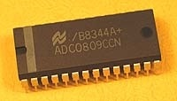

Fig 4.3.1 Diagram of ADC

The ADC0808, ADC0809 data acquisition component is a monolithic CMOS device with an 8-bit analog-to-digital converter, 8-channel multiplexer and microprocessor compatible control logic.

The ADC0809 data acquisition component is a monolithic CMOS device with an 8-bit analog-to-digital converter, 8-channel multiplexer and microprocessor compatible control logic. The 8-bit A/D converter uses successive approximation as the conversion technique.

The design of the ADC0808, ADC0809 has been optimized by incorporating the most desirable aspects of several A/D conversion techniques. The ADC0808, ADC0809 offers high speed, high accuracy, minimal temperature dependence, excellent long-term accuracy and repeatability, and consumes minimal power.

These features make this device ideally suited to applications from process and machine control to consumer and automotive applications. For 16-channel multiplexer with common output (sample/hold port) see ADC0816 data sheet.

**4.4 BUZZER**

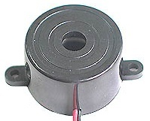

Fig 4.4 Buzzer

A buzzer or beeper [(BUZZERS)](http://www.innovision.us/Buzzers.htm)is a signalling device, usually electronic, typically used in [automobiles](http://en.wikipedia.org/wiki/Automobile), household appliances such as a [microwave oven](http://en.wikipedia.org/wiki/Microwave_oven), or [game shows](http://en.wikipedia.org/wiki/Game_show). It most commonly consists of a number of [switches](http://en.wikipedia.org/wiki/Switch) or [sensors](http://en.wikipedia.org/wiki/Sensor) connected to a control unit that determines if and which button was pushed or a preset time has lapsed, and usually illuminates a light on the appropriate button or control panel, and sounds a warning in the form of a continuous or intermittent buzzing or beeping [sound](http://en.wikipedia.org/wiki/Sound). Initially this device was based on an electromechanical system which was identical to an [electric bell](http://en.wikipedia.org/wiki/Electric_bell) without the metal gong (which makes the ringing noise). Often these units were anchored to a wall or ceiling and used the ceiling or wall as a sounding board. Another implementation with some AC-connected devices was to implement a circuit to make the AC current into a noise loud enough to drive a loudspeaker and hook this circuit up to a cheap 8-ohm speaker. Nowadays, it is more popular to use a ceramic-based [piezoelectric](http://en.wikipedia.org/wiki/Piezoelectric) sounder which makes a high-pitched tone. Usually these were hooked up to "driver" circuits which varied the pitch of the sound or pulsed the sound on and off.

**Features:**

• Rated Frequency: 3,100Hz  
• Operating Voltage: 3 - 20Vdc  
• Current Consumption: 14mA @ 12Vdc  
• Sound Pressure Level (30cm): 73dB @ 12Vdc  
• King State Buzzer - KPE-200  
• Dimensions: 22.5mm Diameter, 19mm High, 29mm between mounting holes

**Application:**

* [Annunciate panels](http://en.wikipedia.org/wiki/Annunciator_panel)
* Electronic [metronomes](http://en.wikipedia.org/wiki/Metronome)
* [Game shows](http://en.wikipedia.org/wiki/Game_show)
* [Microwave ovens](http://en.wikipedia.org/wiki/Microwave_oven) and other [household appliances](http://en.wikipedia.org/wiki/Major_appliance)

**4.5 CURRENT SENSOR**

A **current sensor** is a device that detects electrical current (AC or DC) in a wire, and generates a signal proportional to it.

The sensed current and the output signal can be:

* AC current input,
  + analog output, which duplicates the wave shape of the sensed current
  + unipolar output, which is proportional to the average or RMS value of the sensed current
* DC current input,
  + unipolar, with a unipolar output, which duplicates the wave shape of the sensed current
  + bipolar output, which duplicates the wave shape of the sensed current
  + digital output, which switches when the sensed current exceeds a certain threshold

**FEATURES:**

* Measures current from 1 to 10 A*mps*.
* Tin-silver over copper terminations
* 0.5 mm minimum wall thickness of the hole
* Sensitivity may be enhanced by increasing primary turns.

**4.6 IR SENSOR:**

**4.6.1 OVERVIEW OF IR SENSOR**

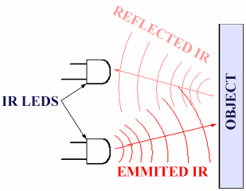

Fig 4.6.1 Working diagram of IR sensor

This sensor can be used for most indoor applications where no important ambient light is present. For simplicity, this sensor doesn't provide ambient light immunity, but a more complicated, ambient light ignoring sensor should be discussed in a coming article. However, this sensor can be used to measure the speed of object moving at a very high speed, like in industry or in tachometers. In such applications, ambient light ignoring sensor, which rely on sending 40 Khz pulsed signals cannot be used because there are time gaps between the pulses where the sensor is 'blind'.

The solution proposed doesn't contain any special components, like photo-diodes, photo-transistors, or IR receiver ICs, only a couple if IR leds, an Op amp, a transistor and a couple of resistors. In need, as the title says, a standard IR led is used for the purpose of detection. Due to that fact, the circuit is extremely simple, and any novice electronics hobbyist can easily understand and build it.

|  |
| --- |
| **4.6.2 OBJECT DETECTION USING IR LIGHTS** |

It is the same principle in ALL Infra-Red proximity sensors. The basic idea is to send infra red light through IR-LEDs, which is then reflected by any object in front of the sensor.

Then all you have to do is to pick-up the reflected IR light. **For detecting the reflected IR light, we are going to use a very original technique: we are going to use another IR-LED**, to detect the IR light that was emitted from another led of the exact same type!  
This is an electrical property of Light Emitting Diodes (LEDs) which is the fact that a led Produce a voltage difference across its leads when it is subjected to light. As if it was a photo-cell, but with much lower output current. In other words, the voltage generated by the leds can't be - in any way - used to generate electrical power from light, It can barely be detected. that's why as you will notice in the schematic, we are going to use a Op-Amp (operational Amplifier) to accurately detect very small voltage changes

**4.7 LCD**

* Pin-1 Vss- Ground
* Pin-2 VDD- Power 5V
* Pin-3 VEE- LCD Contrast Adjustment

**RS- Register Select**

There are 2 very important registers in LCD

* Command Code register
* Data Register

If RS=0 , Instruction command Code register is selected, allowing user to send command. RS=1 , Data register is selected allowing to send data that has to be displayed.

**R\W- Read\Write**

R\W input allows the user to write information to LCD or read information from it. How do we read data from LCD. The data that is being currently displayed will be stored in a buffer memory DDRAM. This data could be read if necessary.

If R\W=0 , Reading

R\W=1 , Writing

**E- Enable**

The enable Pin is used by the LCD to latch information at its data pins. When data is supplied to data pins, a high to low pulse must be applied to this pin in order for the LCD to latch the data present in the data pins.

**General Explanation**

We have to prepare an LCD properly before the character we need, has to be displayed. For this a number of commands have to be provided to the LCD before inputting the required data. The commands will be discussed in the later part of this tutorial.

LCD doesn’t know about the content (data or commands) supplied to its data bus. It is the user who has to specify whether the content at its data pins are data or commands.   For this, if a command is inputted then a particular combination of 0s and 1s has to be applied to the Control lines so as to specify it is a Command on the other hand if a data is inputted at the data lines then an another combination of 0s and 1s has to be applied to the control lines to specify it is Data. (Hope you are not confused!!!!). The combinations are as follows-

If Command ,RS=0, R\W=0, E=1\0 and Data,RS=1, R\W=0, E=1\0

**Various Commands used in LCDs**

|  |  |  |  |
| --- | --- | --- | --- |
| No. | Instruction | Hex | Decimal |
| 1 | Function Set:8bit 1line 5x7 Dots | 0X30 | 48 |
| 2 | Function Set:8bit 2line 5x7 Dots | 0X38 | 56 |
| 3 | Function Set:4bit 1line 5x7 Dots | 0X20 | 32 |
| 4 | Function Set:4bit 2line 5x7 Dots | 0X28 | 40 |
| 5 | Entry Mode | 0X06 | 6 |
| 6 | Display Off,Cursor Off | 0X08 | 8 |
| 7 | Display On,Cursor ON | 0X0E | 14 |
| 8 | Display ON,Cursor blinking | 0X0F | 15 |
| 9 | Shift entire Display Left | 0X18 | 24 |
| 10 | Shift entire Display Right | 0X1C | 30 |
| 11 | Move Cursor Left by One Character | 0X10 | 16 |
| 12 | Move Cursor Right BY One Character | 0X14 | 20 |
| 13 | Clear Display | 0X01 | 1 |

Table 4.6.2 LCD Commands

**Interfacing with PIC**

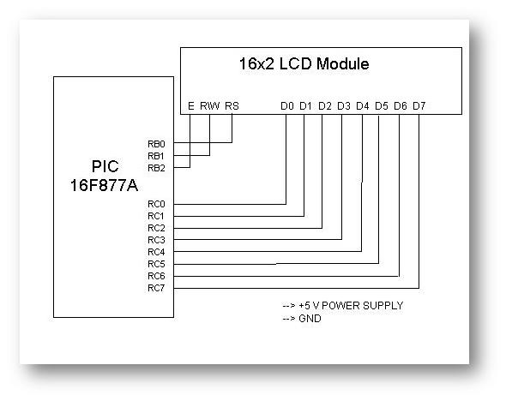

Fig 4.6.3 LCD Interfacing with PIC

Here 2 ports PORT B and PORT C of PIC 16F877A is taken. PORT B is used for providing control signals and PORT C is used for providing Data signals.

**Programming Steps**

* Before sending Data to be Displayed to the LCD, it should be prepared to hold that particular value.
* For this certain initializations are to be done as per the Instructions.
  + Move Value 0X38, 3 times.( Applied max 3 times due to rise time factor)
  + Move Value 0X06, 1 time.
  + Move Value 0X0F, 1 time.
  + After each initializations command function and delay should be called.
* After Initialization Move Data to the LCD

**4.8 VOLTAGE SENSOR**

The interface of various sensors to a controller like the BrainStem GP 1.0 module typically involves either conditioning or converting voltage levels into the range the controller requires.  Many systems use A/D converters to make the sensor value relevant in a program or data logging configuration.  These converters have a fixed range of voltages they can convert from with 0-5V being by far the most common.

Sensors often create voltages in different ranges than those required by the controllers they are being interfaced to which requires the conversion of one voltage to another.  This conversion often breaks down into a combination one or more of three types, amplification, dividing, and shifting. 

**DIVIDING VOLTAGES**

Voltage dividing is probably the easiest transformation you can perform on sensor outputs to alter the value being connected to a microcontroller or other circuit. The mathematical equivalent of what you are trying to achieve when dividing voltages is a simple division.  For instance, say you have a sensor that outputs 0-100V and you want to convert this to 0-5V for interface to the A/D input on your BrainStem.

The goal would be to create a 20:1 ratio of voltage which means dividing the original sensor output voltage by a factor of 20.The easiest way to accomplish this division is using a few resistors to form a voltage divider.The resistors are wired up in series to create intermediate voltages based with the desired division. This voltage divider uses the input as the top of the resistor ladder and ground as the bottom.The actual division is defined by the proportion of resistance between the two resistors.

This is because the resistors used are commonly found resistor values.Precision resistors with exact tolerances can be used but are often not needed since the original output of sensors typically varies.Here the resulting output voltage is slightly below the maximum of 5V but with a reasonable A/D converter like the 10-bit converters used in the BrainStem GP 1.0 module would still offer plenty of dynamic range in the sensor readings. 

**AMPLIFYING VOLTAGES**

Voltage amplification is required for a class of sensors that create small voltages.Often sensors of this type are converting some sort of physical energy such as acceleration, temperature, or other minimal physical force into a voltage.This conversion is often an inefficient conversion and the measured energy is minimal which results in very small voltages generated by the sensor.To make these small voltages meaningful, they must be amplified to a usable level.

The equation for amplification is the exact opposite of dividing.You want to multiply the output voltage from a sensor to gain the full range of yourA/D input or other interfaced circuit.Lets say you have an accelerometer which measures accelerations in g (gravity) unit .A sensor like this may have a response of 312mV/g which means the sensor will generate 0.312V for each gravity unit of force it encounters.Now, say you would like to measure up to 2 gravity units (2g) with your detector with the full range of your 0-5V A/D converter.This means you need to multiply the output voltage of your accelerometer by a factor of about 16 to get the desired range and sensitivity in your measurements.So we want to accomplish the following pictorially:

Probably the most common way to multiply a voltage is using an amplifier.Here, we will use a common Operational Amplifier (Op Amp) to multiply the voltage.These Op Amp circuits are extremely common in electronics and there are volumes of literature devoted specifically to the various characteristics and performance of each.We use one of the original versions which is widely available and easy to interface called the 741.

There are some things to note about this circuit.Again, changing resistance values gives a different voltage amplification (multiplication). The small numbers indicate the pins of the 741 package that you would connect to for this circuit (it is an 8 pin chip).Also, notice the additional power supply which is both positive and negative.This is very common for Op Amp circuits.Since the Op Amp is powered by a plus/minus voltage of 9V, the absolute output can at best be 9V.In practice, the output voltage will probably be slightly less.

The gain for this amplifier may not be exactly linear, depending on the input and output voltages.This can often be hidden in the noise of the sensor and accuracy of the A/D conversion on the other end but it should be considered.The higher the gain of an amplifier, the larger the margin of error and noise.

**SHIFTING VOLTAGES**

Shifting voltages can be a requirement for sensor data that are generated symmetrically about a common (often ground) voltage.A simple example of this would be a motor acting as a generator where spinning in one direction creates a positive voltage and spinning in the other direction creates a negative voltage.Since most common A/D converters in microcontrollers deal with a 0-VCC range for conversions, sensors that are symmetric about the ground voltage reference need to be shifted into the 0-VCC range.

The equation for shifting is then then the addition or subtraction of an offset from the original sensor's voltage.For example, if your sensor produces -2 to 2V, you would want to add 2V to the output for reading with a common 0-5V A/D converter.This addition would result in a final output of 0-4V which the A/D converter could then use.This conversion looks like this pictorially:

This circuit is a two-stage summing amplifier using an Op-Amp chip (the 1458) that houses two op-amps on a single chip.Notice there are some fixed values of resistors that essentially create a voltage summing circuit.The input on one side is a resistor network that creates a fixed voltage to sum with the input voltage.The variable resistor values change this resistor network's set voltage.You could substitute a potentiometer for R1 and R2 to make the addition variable, by twisting the potentiometer.

The addition circuit also requires a plus/minus 9V power supply for the op-amps.In addition, a tap from the 5V supply used for the logic is used although this could be done with the positive 9V side as well, provided the voltages are computed correctly.

**COMBINING CONVERSIONS**

So the above conversions define addition, subtraction, multiplication, and division of a voltage.Each of these conversions can be thought of in isolation as shown above or they can be combined to create composite conversions.We essentially have an algebra of blocks we can use to achieve a wide variety of overall conversions. Say you have a sensor that creates -100 to 100V and you want to read the value with a 0-5V A/D converter.You would need to scale down the original voltage to -2.5 to 2.5V first and then offset the result by adding 2.5V to get the result into the desired range of 0-5V for your A/D converterYou can chain together the conversions for such an effect which would look like this pictorially.

**CONVERSION IMPURITIES**

The above conversions all introduce impurities in the resulting signal in the form of noise, non-linearity, and other corruptions of the original input voltage.Care must be taken to minimize the number of stages and also to order them for reduced error.Testing and careful thought can typically reduce these impurities to a minimum but they cannot be disregarded.

There is a general rule of thumb with regard to these introduced impurities.The more you are changing the original voltage, the more impurities you will introduce.For instance, an amplification of 100x would be generally more noisy than one of 2x.

**POWER SUPPLY ISSUES**

Several of these circuits require a plus/minus 9V supply for the Op Amps.This can readily be accomplished using two standard 9V batteries.More sophisticated options include standard power supplies, charge pumps and inverters and several other options.The 9V battery is cheap, simple and it works well.Op Amp circuits tend to be pretty efficient so the batteries should last quite some time.

**CHAPTER -5**

**SOFTWARE DESCRIPTION**

**5.1 SOFTWARE ANALYSIS**

### Introduction

### The main purpose of using the microcontroller in our project is because high-performance CMOS 8-bit microcontroller with 8K bytes of in-system programmable Flash memory.By combining a versatile 8-bit CPU with in-system programmable Flash on a monolithic chip, the Atmel AT89S52 is a powerful microcontroller which provides a highly-flexible and cost-effective solution to many embedded control applications.The programs of the microcontroller have been written in Embedded C language and were compiled using KEIL, a compiler used for microcontroller programming. The communication between PC and the microcontroller was established MAX 232 standard and those programs were also done in C language.

### 5.2 KEIL compiler

### The C programming language is a general-purpose, programming language that provides code efficiency, elements of structured programming, and a rich set of operators. C is not a big language and is not designed for any one particular area of application.Its generality combined with its absence of restrictions, makes C a convenient and effective programming solution for a wide variety of software tasks.Many applications can be solved more easily and efficiently with C than with other more specialized languages.

### The Cx51 Optimizing C Compiler is a complete implementation of the American National Standards Institute (ANSI) standard for the C language. Cx51 is not a universal C compiler adapted for the 8051 target.It is a ground-up implementation dedicated to generating extremely fast and compact code for the 8051 microprocessor.Cx51 provides you the flexibility of programming in C and the code efficiency and speed of assembly language.Since Cx51 is a cross compiler, some aspects of the C programming language and standard libraries are altered or enhanced to address the peculiarities of an embedded target processor.

### Support for all 8051 Variants

### The 8051 Family is one of the fastest growing Microcontroller Architectures.More than 400 device variants from various silicon vendors are today available.New extended 8051 Devices, like the Philips 80C51MX architecture are dedicated for large application with several Mbytes code and data space.For optimum support of these different 8051 variants, Keil provides the several development tools that are listed in the table below.A new output file format (OMF2) allows direct support of up to 16MB code and data space.The CX51 compiler is a variant of the C51 compiler that is design for the new Philips 80C51MX architecture.

### Compiling with Cx51

### This explains how to use Cx51 to compile C source files and discusses the control directives you may specify.These directives allow you to perform several functions. For example:

### Direct Cx51 to generate a listing file.

### Control the information included in the object file.

### Specify code optimization and memory models

### Running Cx51 from the Command Prompt

### To invoke the C51 or CX51 compiler, enter C51 or CX51 at the command prompt. On this command line, you must include the name of the C source file to be compiled, as well as any other necessary control directives required to compile your source file.

### The format for the Cx51 command line is shown below:

### C51 source file _directives…_

### CX51 source file _directives…_

### where:

### Source file is the name of the source program you want to compile.

### Directives are the directives you want to use to control the function of the compiler.

### Command file is the name of a command input file that may contain source file and directives. A command file is used, when the Cx51 invocation line gets complex and exceeds the limits of the Windows command prompt.

### The following command line example invokes C51, specifies the source file

### SAMPLE.C, and uses the controls DEBUG, CODE, and PREPRINT.

### C51 SAMPLE.C DEBUG CODE PREPRINT

### The Cx51 compiler displays the following information upon successful

### invocation and compilation.

### C51 COMPILER V6.10

### C51 COMPILATION COMPLETE. 0 WARNING(S), 0 ERROR(S)

### 8051 Derivatives

### A number of 8051 derivatives are available that provide enhanced Performance while remaining compatible with the 8051 core.These derivatives provide additional data pointers, very fast math operations, and reduced instruction sets.The Cx51 compiler directly supports the enhanced features of the following 8051-based microcontrollers:

### Atmel 89x8252 and variants (2 data pointers).

### Dallas 80C320, 80C420, 80C520, 80C530, 80C550 an variants (2 data pointers).

### Infineon C517, C517A, C509, and variants (high-speed 32-bit and 16-bit binary

### arithmetic operations, 8 data pointers).

### Philips 8xC750, 8xC751, and 8xC752 (maximum code space of 2 KBytes, no LCALL

### or LJMP instructions, 64 bytes internal, no external data memory).

### Philips and Temic support on several device variants 2 data pointers.

### The C51 compiler provides you with support for these CPUs through the use of special libraries, library routines, and the MODxxx command-line directives.These directives enable C51 to generate object code that takes advantage of the enhancements mentioned above.

### Atmel 89x8252 and variants

### The Atmel 89x8252 and variants provide 2 data pointers which can be used for memory access.Using multiple data pointers can improve the speed of library functions like memcpy, memmove, memcmp, strcpy, and strcmp. The MODA2 control directive instructs the C51 compiler to generate code that uses both data pointers in your program.The C51 compiler uses at least one data pointer in an interrupt function. If an interrupt function is compiled using the MODA2 directive, both data pointers are saved on the stack. This happens even if the interrupt function uses only one data pointer. The C51 compiler does not use the second data pointer when this directive is used.

### 5.3 KEIL MICROVISION:

### Keil MicroVision is a free software which solves many of the pain points for an embedded program developer.This software is an integrated development environment (IDE), which integrated a text editor to write programs, a compiler and it will convert your source code to hex files too.

### CHAPTER 6

### IMPLEMENTATION

**6.1 EMBEDDED C CODING FOR MICROCONTROLLER**

#include <REGX51.H>

#define MYDATA P0

sbit rs=P3^2;

sbit rw=P3^3;

sbit en=P3^4;

sfr datas=0xA0;

sbit A1=P1^0;

sbit A2=P1^1;

sbit A3=P1^2;

void lcdinit(void);

void lcdcmd(unsigned char );

void delay(unsigned int del);

void lcddata(unsigned char ldat);

void lcdinit(void)

{

lcdcmd(0x38);

lcdcmd(0x38);

lcdcmd(0x38);

lcdcmd(0x06);

lcdcmd(0x0e);

lcdcmd(0x01);

lcdcmd(0x0C);

lcdcmd(0x80);

}

void lcdcmd(unsigned char lcmd)

{

datas=lcmd;

rs=0;

rw=0;

en=1;

delay(50);

en=0;

} void delay(unsigned int del)

{

while(del--); }

void lcddata(unsigned char ldat)

{

datas=ldat;

rs=1;

rw=0;

en=1;

delay(50);

en=0;

}

void Delay()

{

int i;

for(i=0;i<12000;i++);

}

void init()

{

SCON=0x50;

TMOD=0X20;

TH1=0XFd;

TR1=1;

}

void txs(unsigned char value)

{

int i;

TI=0;

SBUF=value;

while(TI==0);

for(i=0;i<6000;i++);

}

unsigned char val1[6],val,sp,spt,sptt;

void putchar(unsigned char val[16],char len)

{

char i;

for(i=0;i<len;i++)

{

lcddata(val[i]);

}

}

char ii;

long ll;

void main()

{

int i=0,v=200,v1=0,d=0,er=0,cnt1=0,ff=0;

unsigned int hb=0,cnt=0,cur=0;

init();

lcdinit();

txs('A');txs('T');txs(13); txs(10);

lcdcmd(0x80);

putchar("Show Card ",16);

while(P3_6==1);

P1_7=1;

P1_6=1;

P1_5=1;

P1_4=1;

P1_3=1;

lcdcmd(0x80);

putchar("Enter Amount ",16);

while(cnt1==0)

{

if(P1_7==0)

cnt1=300;

if(P1_6==0)

cnt1=200;

if(P1_5==0)

cnt1=100;

if(P1_4==0)

cnt1=50;

}

// cnt1=cnt1+100;

lcdcmd(0x80);

putchar(" ",16);

while(1)

{

while(RI==0)

{

P1_0=0;

P1_1=0;

P1_2=0;

Delay();

val1[0]=MYDATA;

lcdcmd(0xC0);

lcddata('V');

lcddata('=');

lcddata((val1[0]/100)+0x30);

lcddata(((val1[0]%100)/10)+0x30);

lcddata((val1[0]%10)+0x30);

P1_0=1;

P1_1=0;

P1_2=0;

Delay();

val1[1]=MYDATA;

lcdcmd(0x86);

lcddata('I');

lcddata('=');

lcddata((val1[1]/100)+0x30);

lcddata(((val1[1]%100)/10)+0x30);

lcddata((val1[1]%10)+0x30);

if(P3_5==0)

{

while(P3_5==0);

if(cnt1>0)

cnt1=cnt1-5;

}

if(cnt1==0)

{

P1_3=0;

}

else

{

P1_3=1;

}

if(cnt1<=20) {

if(P1_7==0)

cnt1=cnt1+300;

if(P1_6==0)

cnt1=cnt1+200;

if(P1_5==0)

cnt1=cnt1+100;

if(P1_4==0)

cnt1=cnt1+50;

P3_7=0;

lcdcmd(0xC8);

lcddata('R');

lcddata('e');

lcddata('c');

lcddata('h');

lcddata('a');

lcddata('r');

lcddata('g');

lcddata('e');

lcddata(' ');

lcddata(' ');

}

else

{

P3_7=1;

}

/* if(val1[1]>35)

{

if(ll==0)

{

if(cnt1>10)

cnt1=cnt1-10;

else

cnt1=0;

ll=100;

}

}

else if(val1[1]>15)

{

if(ll==0)

{

if(cnt1>50)

cnt1=cnt1-5;

else

cnt1=0;

ll=100;

}

}

if(ll>0)

ll--;

if(cnt1<=10)

{

if(P3_5==0)

{

if(P1_7==0)

{

cnt1=cnt1+50;

P3_7=1;

P1_2=1;

}

if(P1_6==0)

{

cnt1=cnt1+100;

P3_7=1;

P1_2=1;

}

if(P1_5==0)

{

cnt1=cnt1+150;

P3_7=1;

P1_2=1;

}

}

lcdcmd(0xCD);

lcddata('P');

lcddata('a');

lcddata('y');

}

else

{

lcdcmd(0xCD);

lcddata(' ');

lcddata(' ');

lcddata(' ');

lcddata(' ');

}

if(cnt1<=0)

{

cnt1=0;

P3_7=0;

P3_6=0;

}

lcdcmd(0x80);

lcddata('M');

lcddata('=');

lcddata(((cnt1%1000)/100)+0x30);

lcddata(((cnt1%100)/10)+0x30);

lcddata((cnt1%10)+0x30);

cnt++;

if(cnt>=30)

{

cnt=0;

txs('A');

txs(((cnt1%1000)/100)+0x30);

txs(((cnt1%100)/10)+0x30);

txs((cnt1%10)+0x30);

txs('B');

txs((val1[0]/100)+0x30);

txs(((val1[0]%100)/10)+0x30);

txs((val1[0]%10)+0x30);

txs('C');

txs((val1[1]/100)+0x30);

txs(((val1[1]%100)/10)+0x30);

txs((val1[1]%10)+0x30);

txs('D');

}

}

val1[ii]=SBUF;

RI=0;

ii++;

if(ii==2)

{

ii=0;

lcdcmd(0x8E);

lcddata(val1[0]);

lcddata(val1[1]);

if(val1[0]=='T')

{

P1_3=1;

}

if(val1[0]=='U')

{

P1_3=0;

}

if(val1[1]=='T')

{

P1_3=1;

}

if(val1[1]=='U')

{

P1_3=0;}

}

}

}

**6.2 SCREENSHOTS:**

**KEIL IDE 4 WORKING PROCEDURE**



Keil 4 IDE Compiler Working Procedure

Double Click the Icon

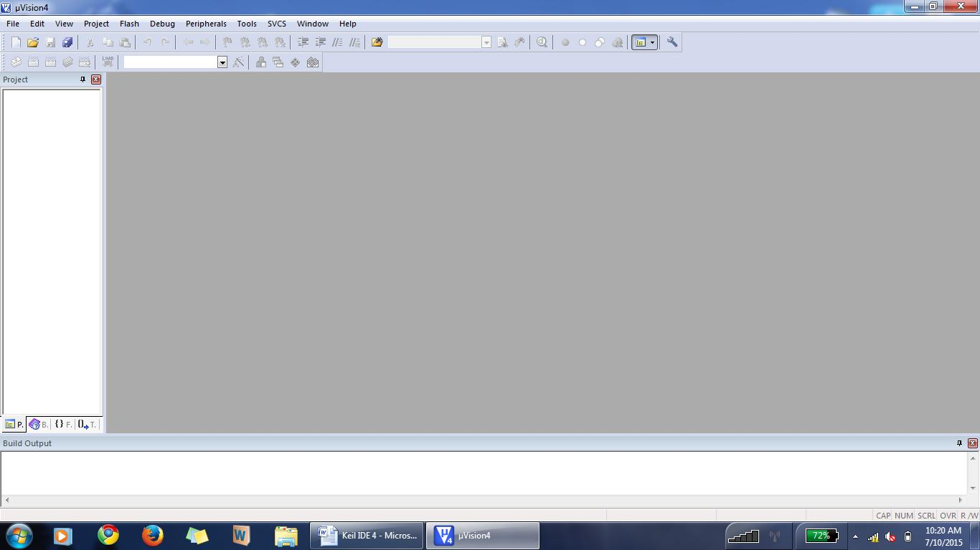

Click “Project”

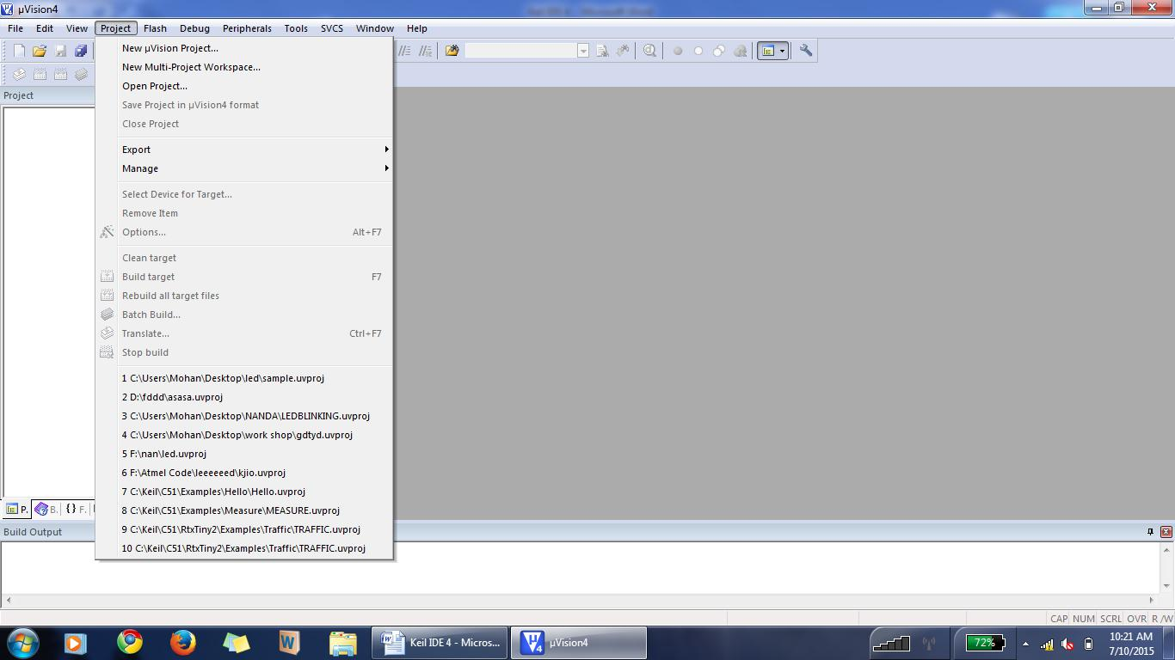

Then Click “New Uvision Project”

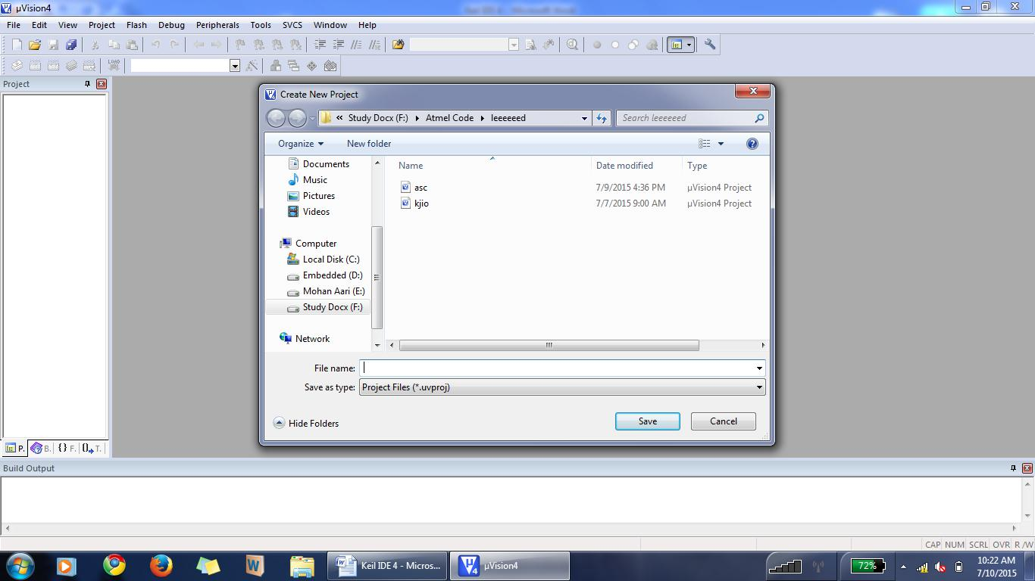

Select The Storage Path

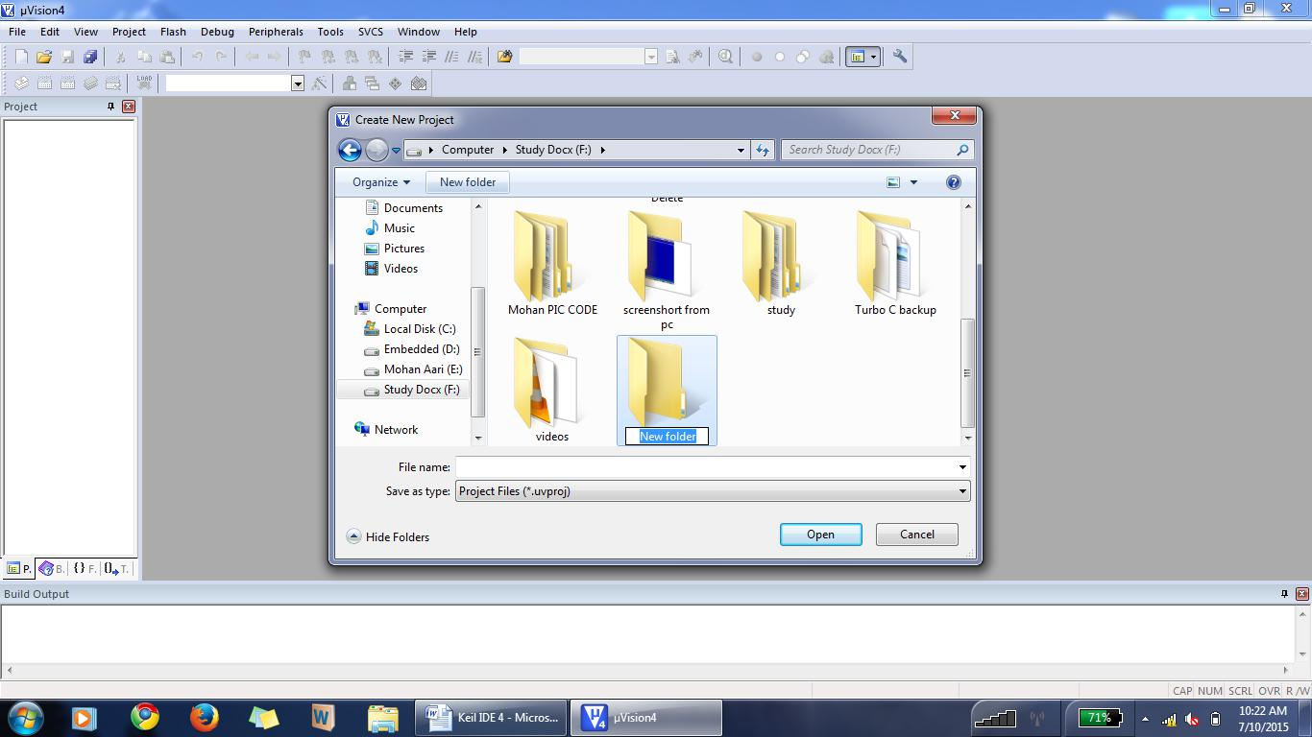

After Path Selection. Create “New Folder”

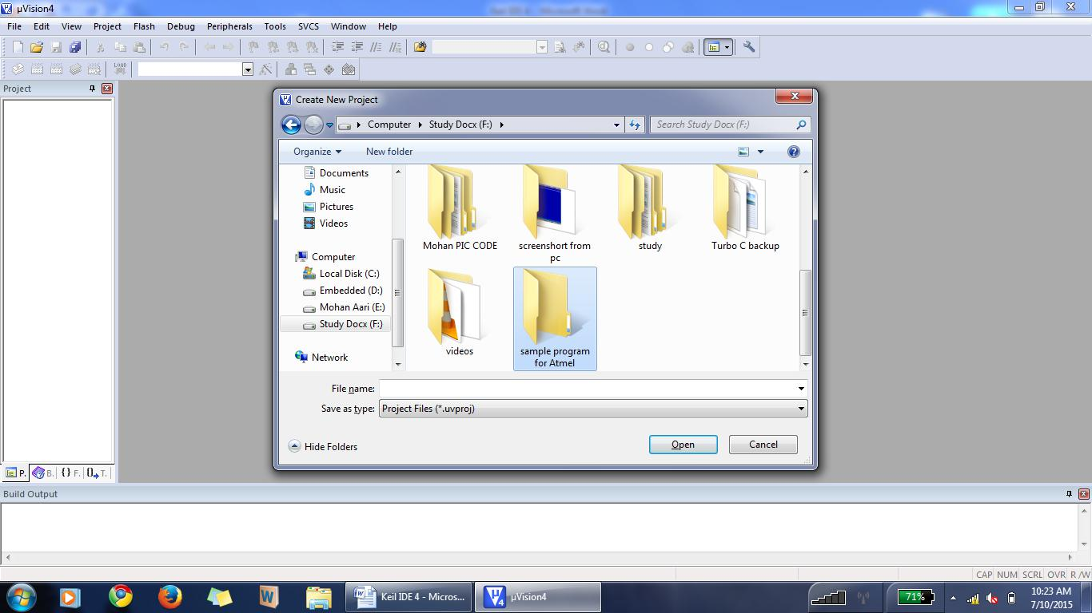

Give The Folder Name & Double Click

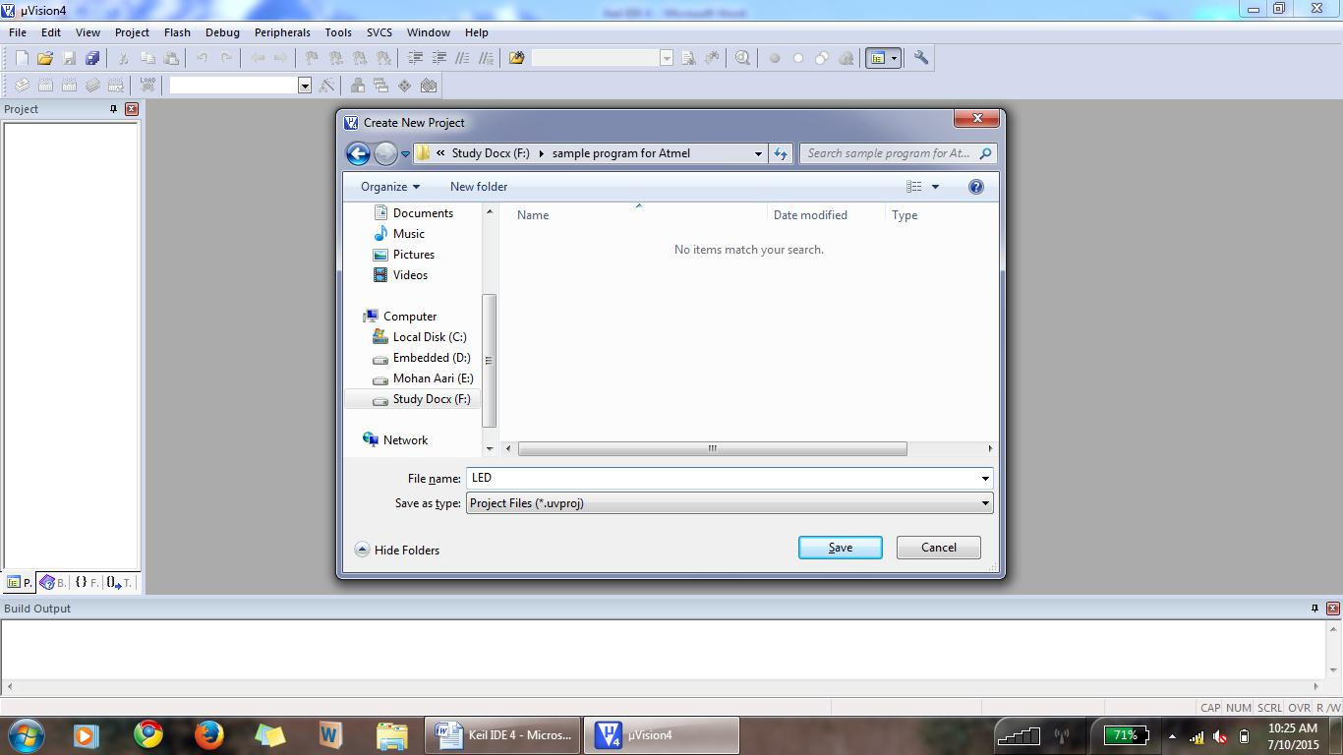

Enter The File Name & Click “save”.

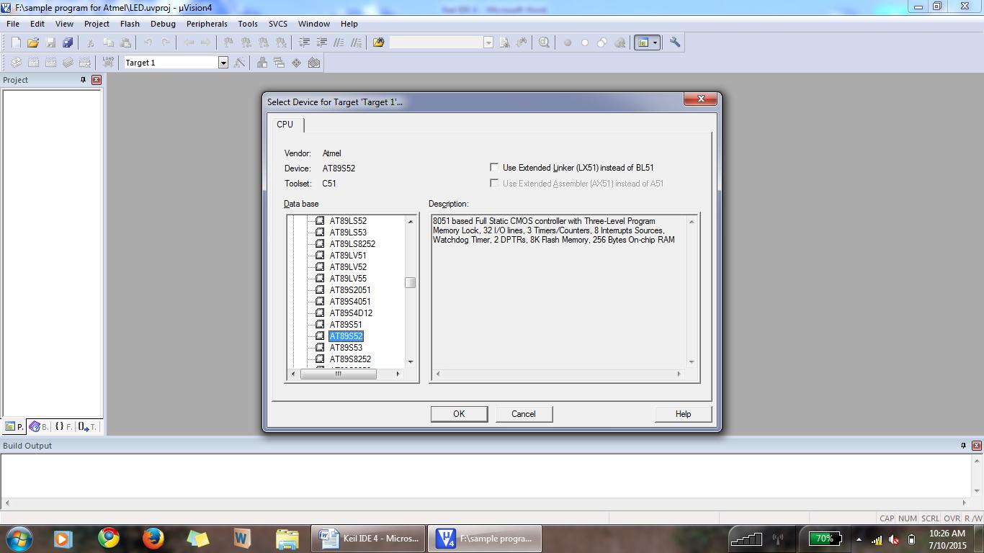

Double Click -->”Atmel”.

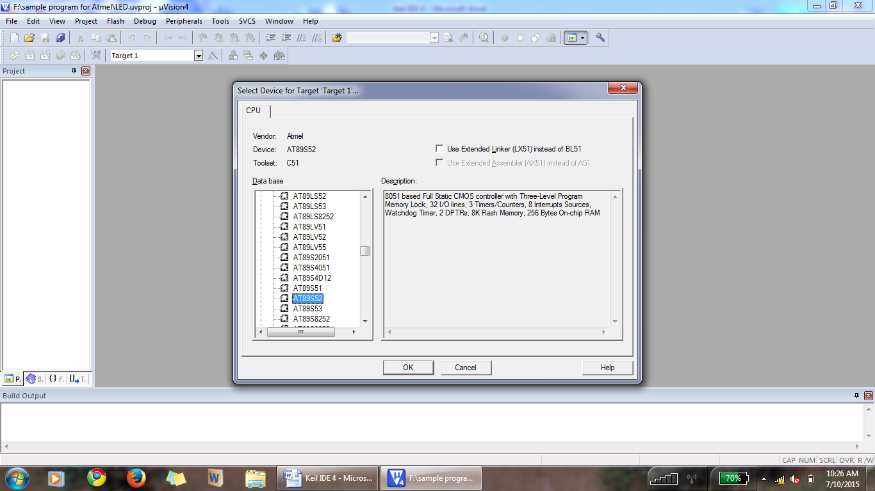

Then Select “AT89S52” & Click “OK”.

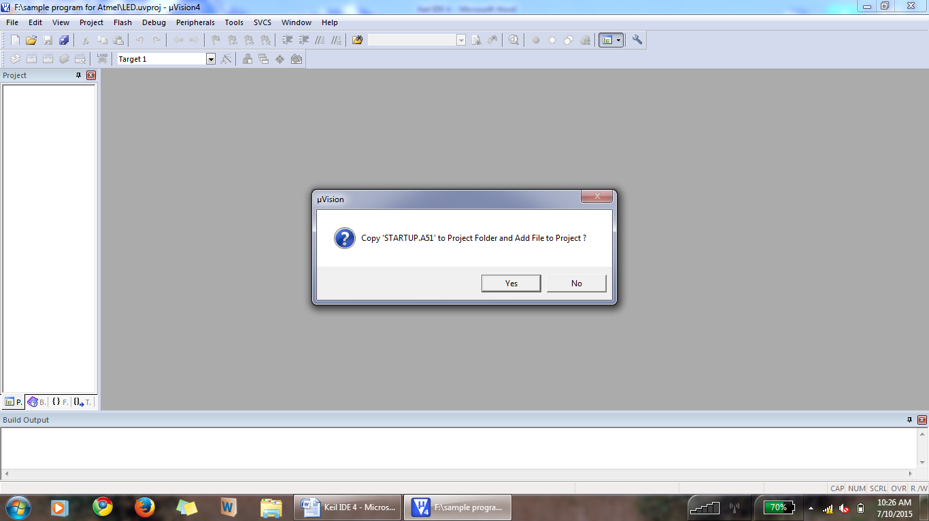

Click -->“YES”

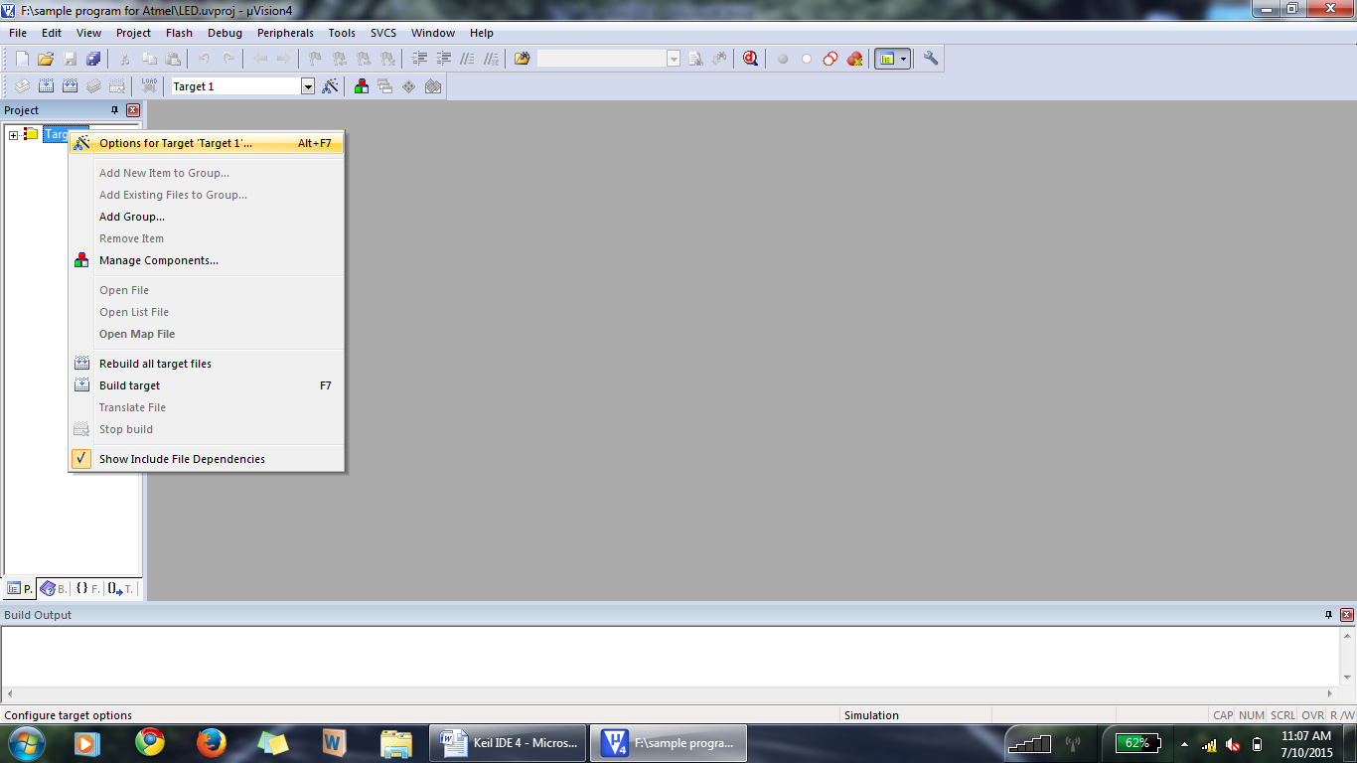

Right Click The ‘Target1’ & Select “Options For Target ‘Target1’”.

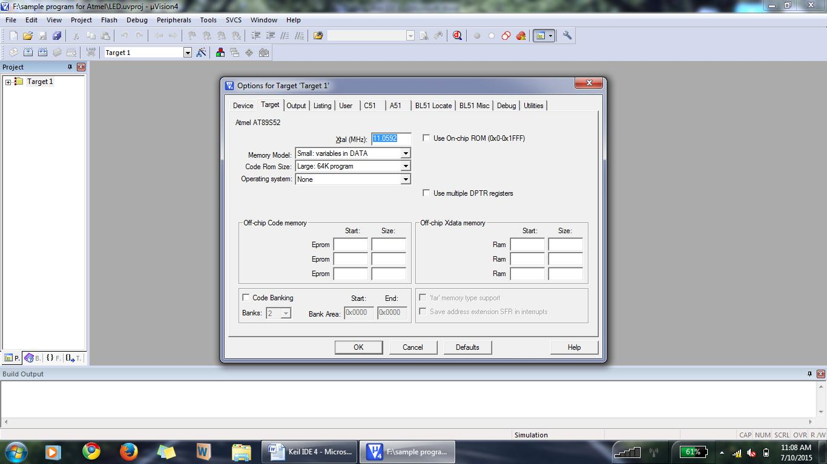

Set The Frequency As 11.0592.

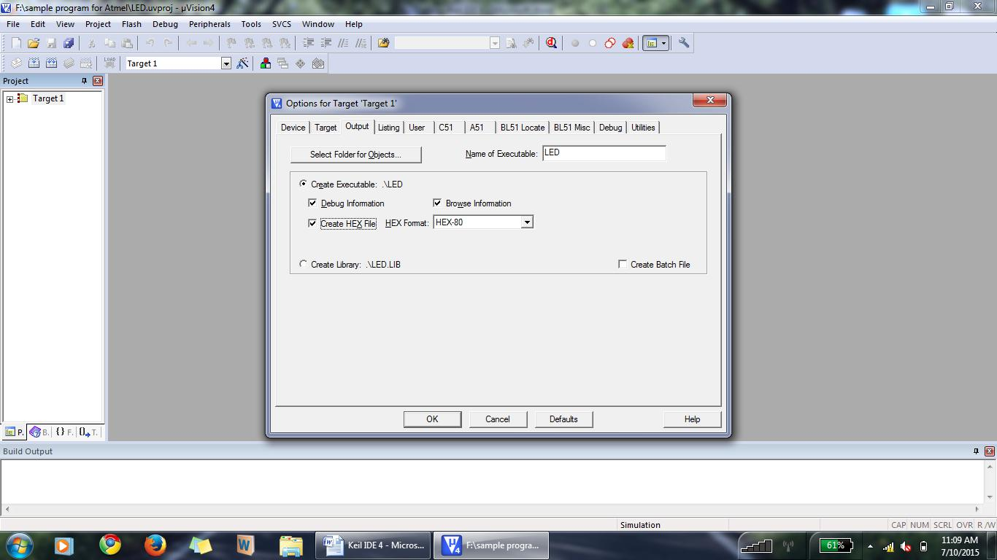

Click-->”Output” & Select “Create HEX File”.

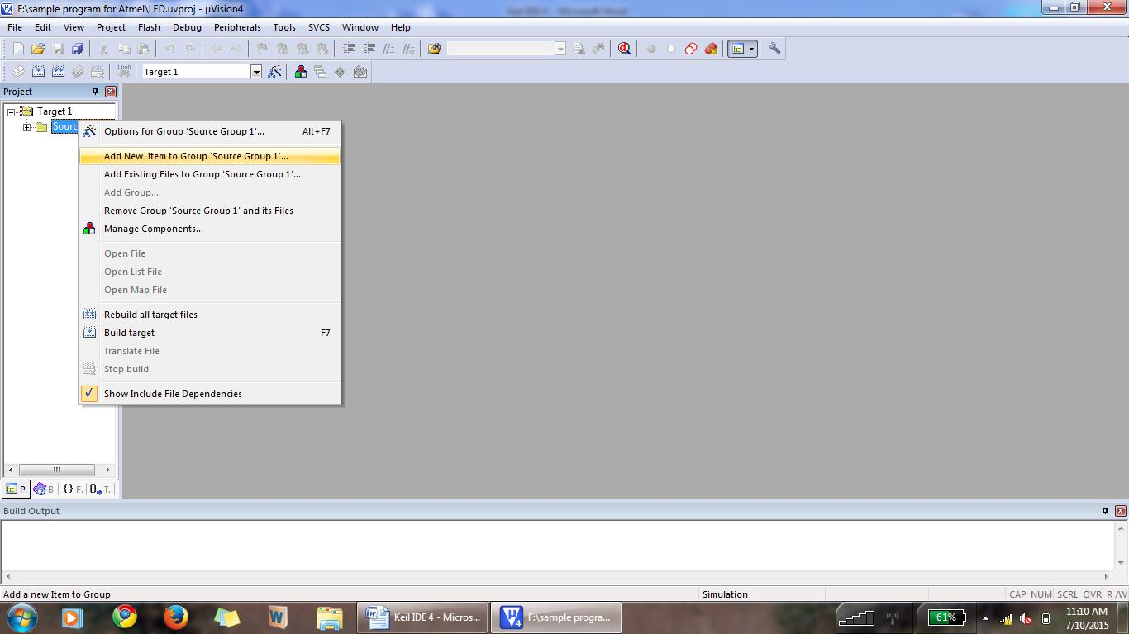

If “source Group 1” is not available Just Click the + symbol Which is before the ‘Target1’.

Right Click The “Source Group 1” & Select “Add New Item To Group ‘Source Group 1’”.

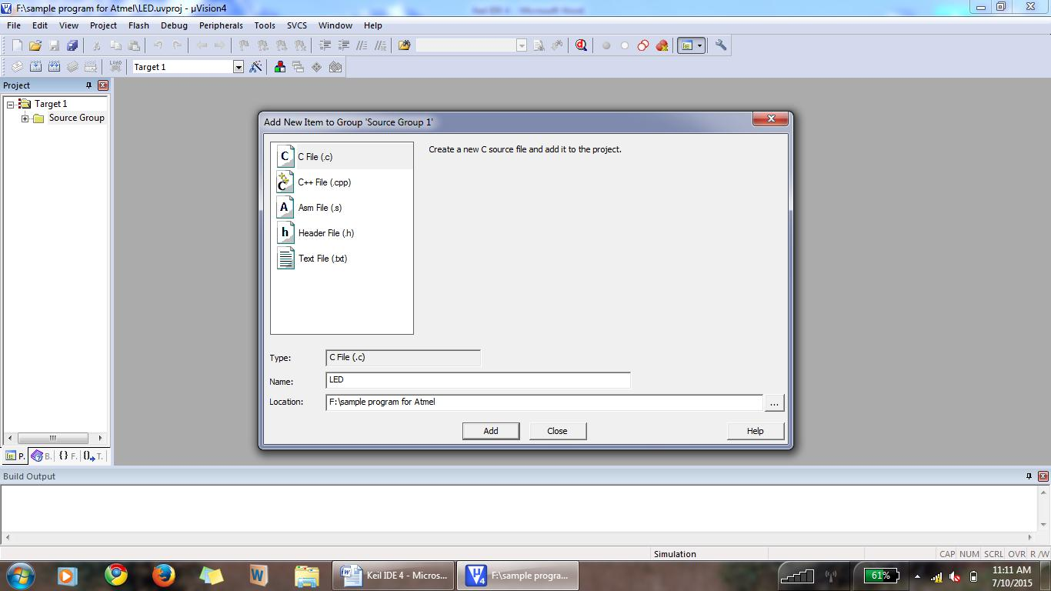

Select The File Type As “C File(.c)” & Give The File Name Then Click “ADD”.

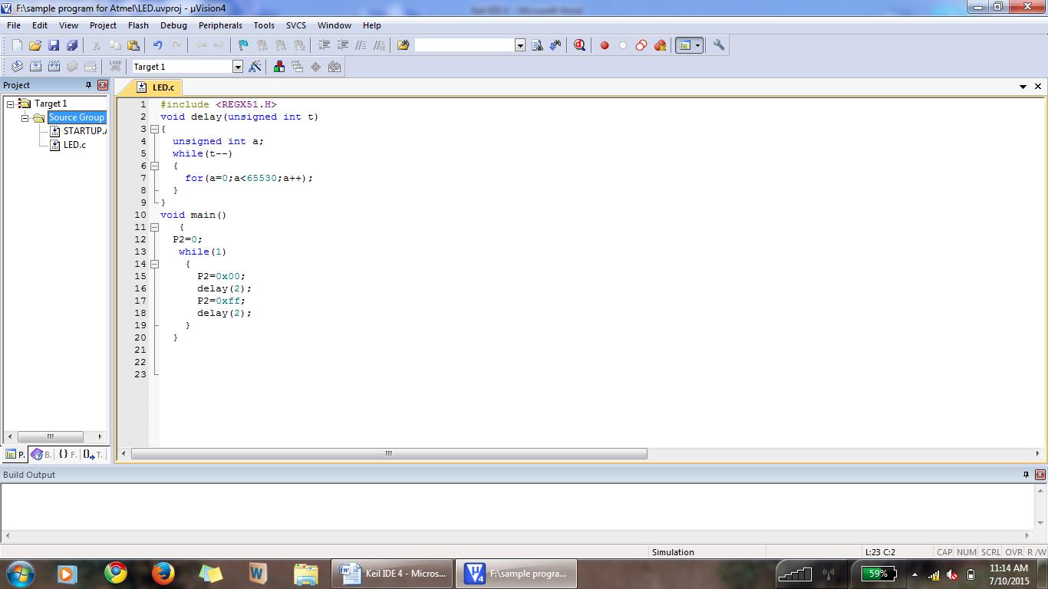

Type The Program Here & Save The File By File-->Save/Ctrl+S.



For Build/Compile--> Click “Build” Icon/F7.

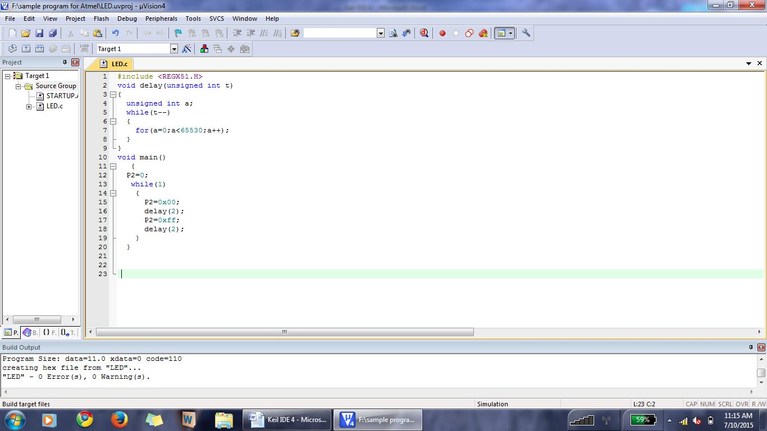

After Compilation “Error Status” Will Be Shown Here.

### 

### 

### CHAPTER-7

### CONCLUSION

This paper describes the implemented simulation framework for PLC and prepaid metering system and it also reduces the voltage fluctuation. In contrast to other studies, simulations carried out take into account all the processes in the communication layer stack.

### The benefit of the approach presented is that, Prepaid meter prevents the person from heavy billing. Easy to implement in smart cities. It can reduce the man power also avoids voltage fluctuation.

The authors also believe that this simulation framework could result in an interesting tool for utilities when deploying their prepaid metering and fluctuation control solutions using PLCs. With the use of this tool, thus it is a real world application project which benefit the nation.

### REFERENCES

[1] Patrick, A., Newbury, J., and Gargan, S., "Two-way communications systems in the electricity supply industry," IEEE Trans. Power Delivery, Vol.13, pp. 53 -58, Jan. 1998.

[2] Miura, N., Sato, H., Narita, H., and Takaki, M., "Automatic meter-reading system by power line carrier communications," in Proc. C 1990 IEEE Trans Generation, Transmission and Distribution, Vol. 137 Issue: 1, pp. 25 -31.

[3] Donovan, D., "Cellular control channel communications for distribution automation applications," in Proc. 2001 IEEE/PES Transmission and Distribution Conference and Exposition, Vol.2 , pp. 982 -984.

[4] Anderson, H.R., "Measured data transmission performance for AM broadcast-VHF radio distribution 2000 IEE 3G Mobile Communication Technologies Conference, pp. 426-430.

[5] Chakrabarti, S. and Mishra, A., "A network architecture for global wireless position location services," in Proc. 1999 IEEE Communications Conference, Vol.3, pp. 1779-1783.

[6] Constantinos F. Grecas, Sotirios I. Maniatis, and Iakovos S. Venieris, "GIP: an infrastructure for mobile intranets deployment, Wireless Networks," Kluwer Academic Publishers, Vol.9, Issue 4, 2003, pp. 321-330.

[7] Chih-hsien Kung and Devaney, M.J., "Multirate digital power metering,"Instrumentation and Measurement Technology Conference, 1995.

*.*